Kubernetes Task-05
- Create a namespace dev-environment and apply a resource-based quota that restricts the number of pods to 3 and services to 2.
  - Create Namespace
Create a YAML file:
vi namespace.yaml
Paste this:
apiVersion: v1
kind: Namespace
metadata:
name: dev-environment
Apply it:
  - kubectl apply -f namespace.yaml
Verify:
kubectl get ns
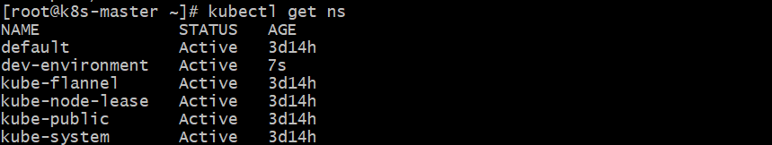

  - Create ResourceQuota
Create another YAML file:
vi resourcequota.yaml
Paste this:
apiVersion: v1
kind: ResourceQuota
metadata:
name: dev-quota
namespace: dev-environment
spec:
hard:
pods: "3"
services: "2"
Apply it:
  - kubectl apply -f resourcequota.yaml
  - Verify Quota
kubectl describe quota dev-quota -n dev-environment
You should see:
Resource Used Hard
-------- ---- ----
pods 0 3
services 0 2
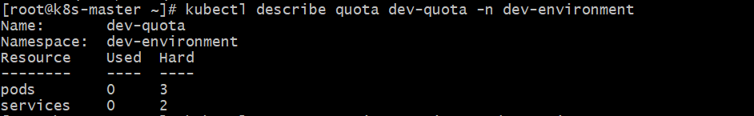
  - Test (Important 🔥)
Try creating 4 pods → 4th should FAIL:
  - kubectl run test1 --image=nginx -n dev-environment
kubectl run test2 --image=nginx -n dev-environment
kubectl run test3 --image=nginx -n dev-environment
kubectl run test4 --image=nginx -n dev-environment
Error will be like:
exceeded quota: dev-quota, requested: pods=1, used: pods=3, limited: pods=3

- Create a pod in the prod-environment namespace with 0.2 CPU and 200Mi memory requests, and 0.5 CPU and 500Mi memory limits.
  - Create YAML file
Create a file:
  - vi prod-pod.yaml
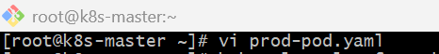
Paste this:
apiVersion: v1
kind: Pod
metadata:
name: prod-pod
namespace: prod-environment
spec:
containers:
- name: nginx
image: nginx
resources:
requests:
cpu: "200m"
memory: "200Mi"
limits:
cpu: "500m"
memory: "500Mi"
  - Apply the Pod
  - kubectl create namespace prod-environment
  - kubectl apply -f prod-pod.yaml
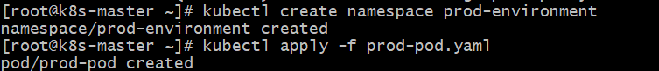
  - Verify Pod
Check if pod is created:
  - kubectl get pods -n prod-environment
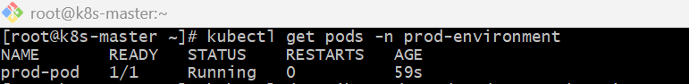
  - Verify Resources Applied
kubectl describe pod prod-pod -n prod-environment
Look for:
Requests:
cpu: 200m
memory: 200Mi
Limits:
cpu: 500m
memory: 500Mi
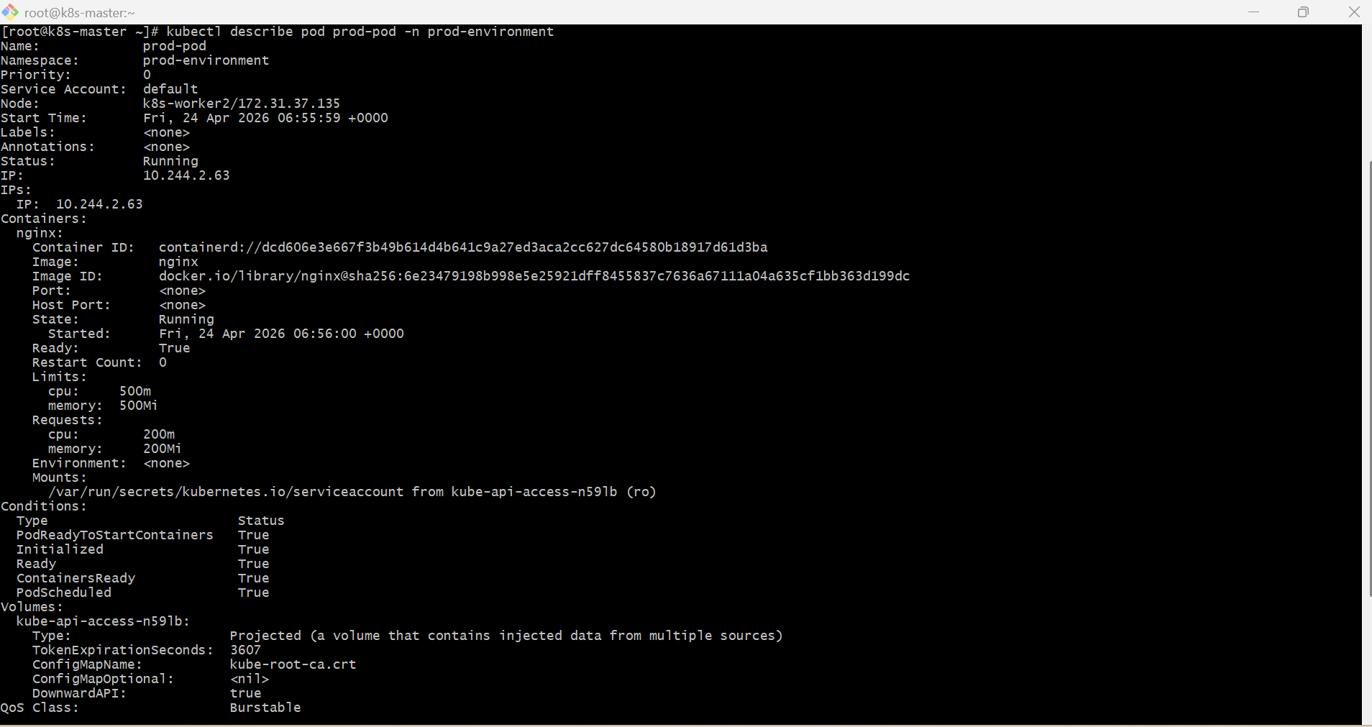
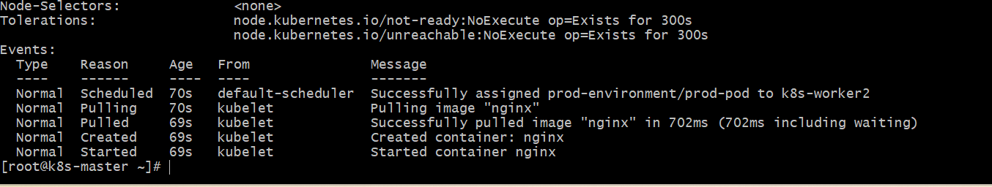

- In the staging-environment namespace, set a LimitRange that assigns default CPU and memory limits (300m CPU, 600Mi memory) and applies a minimum and maximum CPU.
  - Create YAML file
Create a file:
  - vi limitrange.yaml
Paste this:
apiVersion: v1
kind: LimitRange
metadata:
name: cpu-mem-limits
namespace: staging-environment
spec:
limits:
- type: Container
default:
cpu: "300m"
memory: "600Mi"
defaultRequest:
cpu: "100m"
memory: "200Mi"
min:
cpu: "100m"
max:
cpu: "500m"
  - Create the namespace
  - kubectl create namespace staging-environment
  - Verify namespace
kubectl get ns
You should see:
staging-environment
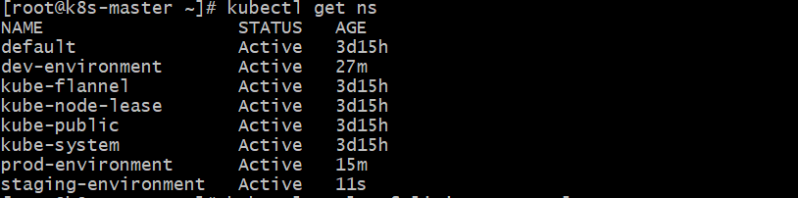

  - Apply the configuration
  - kubectl apply -f limitrange.yaml

  - Verify
Check LimitRange:
  - kubectl get limitrange -n staging-environment
Describe it:
  - kubectl describe limitrange cpu-mem-limits -n staging-environment
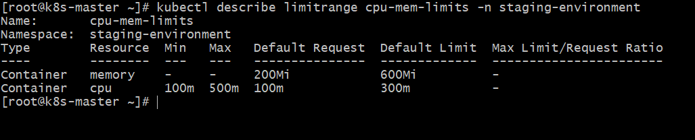
- Create a pod and a NodePort service in the default namespace, then create another pod in the test namespace and communicate between them using Service DNS.
  - vi nginx.yaml
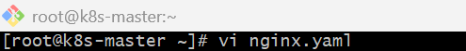
apiVersion: v1
kind: Pod
metadata:
name: nginx-pod
labels:
app: nginx-dns
spec:
containers:
- name: nginx-container
image: nginx
ports:
- containerPort: 80
kubectl apply -f nginx.yaml
  - vi nginx-service.yaml
apiVersion: v1
kind: Service
metadata:
name: nginx-nodeport-svc
spec:
type: NodePort
selector:
app: nginx-dns
ports:
- protocol: TCP
port: 80
targetPort: 80
nodePort: 30082
  - kubectl apply -f nginx-service.yaml
  - kubectl create ns test
  - kubectl get ns
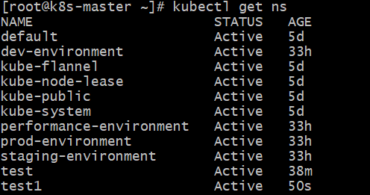

  - kubectl run test1-pod --image=busybox -n test1 --restart=Never --sleep 3600
  - kubectl get pods -n test1
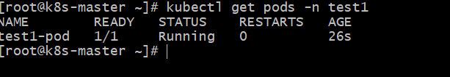
- Apply a LimitRange with a max limit/request ratio of 2 for memory in the performance-environment namespace, and test by creating a pod with mismatched resource requests and limits.
  - Create namespace
kubectl create namespace performance-environment
  - Create LimitRange YAML
vi memory-ratio-limitrange.yaml
Paste:
apiVersion: v1
kind: LimitRange
metadata:
name: memory-ratio-lr
namespace: performance-environment
spec:
limits:
- type: Container
maxLimitRequestRatio:
memory: "2"
Apply:
  - kubectl apply -f memory-ratio-limitrange.yaml
Check:
  - kubectl describe limitrange memory-ratio-lr -n performance-environment
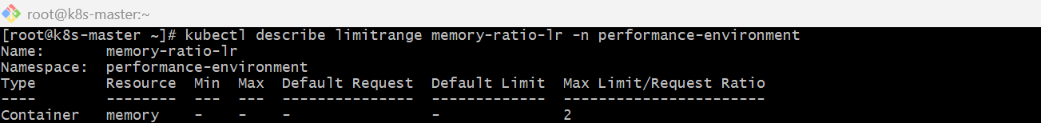
  - Test with invalid pod
This pod has request 100Mi and limit 300Mi.
Ratio = 300 / 100 = 3, so it should fail because max ratio is 2.
  - vi bad-memory-pod.yaml
Paste:
apiVersion: v1
kind: Pod
metadata:
name: bad-memory-pod
namespace: performance-environment
spec:
containers:
- name: nginx
image: nginx
resources:
requests:
memory: "100Mi"
limits:
memory: "300Mi"
Apply:
  - kubectl apply -f bad-memory-pod.yaml
Expected error:
maximum memory usage per Container is 2, but limit is 300Mi and request is 100Mi
  - Test with valid pod
  - vi good-memory-pod.yaml
Paste:
apiVersion: v1
kind: Pod
metadata:
name: good-memory-pod
namespace: performance-environment
spec:
containers:
- name: nginx
image: nginx
resources:
requests:
memory: "100Mi"
limits:
memory: "200Mi"
Apply and verify:
  - kubectl apply -f good-memory-pod.yaml
kubectl get pods -n performance-environment
kubectl describe pod good-memory-pod -n performance-environment
